**Preparing Environment for creating a Deep learning Model with Dental Clinic Data**

**By - Aaditya Balakrishnan**

Step 1 Installed Python v 3.11.4

Step 2 Installed Visual Studio code

Step 3 Installed Anaconda installer for jupyter notebook

Step 4 Installed Python extension in vs code

Step 5 Setting up virtual environment

***Entered command in terminal***

conda create --name yourenvname python=3.11.4

conda env list

conda install ipykernel

conda install pandas

conda install matplotlib

conda install Tensorflow

conda install sklearn

conda install plotly

**Imported the given file – DOCS.csv**

**Sample data**

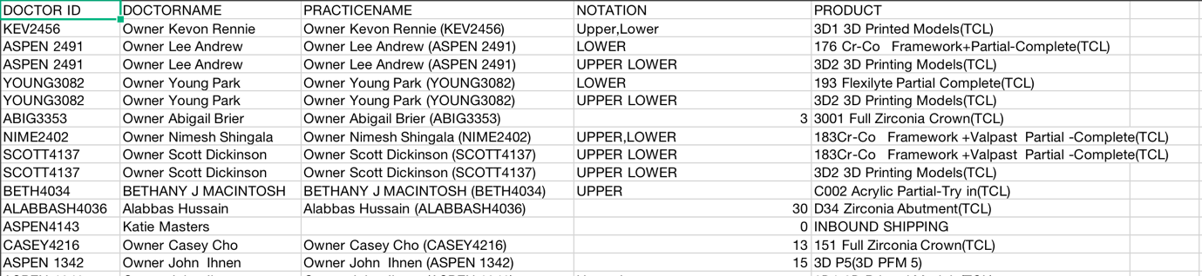

***Coding in VS code***

import numpy as np

import pandas as pd

import matplotlib.pyplot as plt

import pandas as pd

import tensorflow as tf

from tensorflow.keras import layers, models

from sklearn.model_selection import train_test_split

from sklearn.preprocessing import LabelEncoder, OneHotEncoder

from tensorflow.keras import layers, models

**(importing file in csv format)**

data = pd.read_csv("DOCS.csv")

print (data.head)

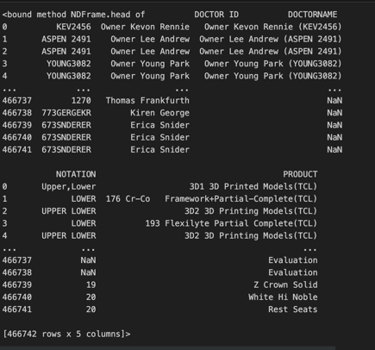

data = data.dropna(how='any')

print(data.shape)

**(Changing values in number format by encoding label)**

from sklearn.preprocessing import LabelEncoder

le=LabelEncoder()

data['DOCTORNAME']=le.fit_transform(data['DOCTORNAME'])

data['PRACTICENAME']=le.fit_transform(data['PRACTICENAME'])

data['NOTATION']=le.fit_transform(data['NOTATION'])

data['PRODUCT']=le.fit_transform(data['PRODUCT'])

data.head()

**(Changing string to INT)**

def handle_non_numerical_data(data):

columns = data.columns.values

for column in columns:

text_digit_vals = {}

def convert_to_int(val):

return text_digit_vals[val]

if data[column].dtype != np.int64 and data[column].dtype != np.float64:

column_contents = data[column].values.tolist()

unique_elements = set(column_contents)

x = 0

for unique in unique_elements:

if unique not in text_digit_vals:

text_digit_vals[unique] = x

x+=1

data[column] = list(map(convert_to_int, data[column]))

return data

data = handle_non_numerical_data(data)

print(data.head())

**(One way)**

(Perfforming Logistic regression by separating data into train and test model)

from sklearn.linear_model import LogisticRegression

from sklearn.model_selection import train_test_split

from sklearn.metrics import accuracy_score

import time

x=data.loc[:,"NOTATION"].values

y=data.loc[:,"PRODUCT"].values

from sklearn.model_selection import train_test_split

x_train,x_test,y_train,y_test=train_test_split(x,y,test_size=0.2,random_state=0)

from sklearn.preprocessing import StandardScaler

sc_x = StandardScaler()

sc_y = StandardScaler()

x_train=np.array(x_train).reshape(-1,1)

x_train= sc_x.fit_transform(x_train)

y_train=np.array(y_train).reshape(-1,1)

x_test = np.array(x_test).reshape(-1,1)

x_test = sc_x.fit_transform(x_test)

y_test_org = y_test

y_test = np.array(y_test).reshape(-1,1)

from sklearn.preprocessing import StandardScaler

sc=StandardScaler()

x_train=sc.fit_transform(x_train)

x_test=sc.fit_transform(x_test)

**(Alternative way)**

def load_data_from_excel(file_path, target_column):

# Assuming the first row contains the column names

data = pd.read_excel(file_path, engine='openpyxl')

# Separate features and labels

features = data.drop(columns=[target_column])

labels = data[target_column]

# Convert labels to one-hot encoded format (if needed)

# For binary classification, you can use `pd.get_dummies(labels)` as well

labels = pd.get_dummies(labels)

return features, labels

# Replace 'data.xlsx' with the path to your Excel file and 'target_column_name' with the name of the target column.

file_path = 'DOCS.xlsx'

target_column_name = 'PRODUCT'

features, labels = load_data_from_excel(file_path, target_column_name)

# Split the data into training and testing sets

X_train, X_test, y_train, y_test = train_test_split(features, labels, test_size=0.2, random_state=42)

def create_deep_learning_model(input_shape, num_classes):

model = models.Sequential([

layers.Dense(64, activation='relu', input_shape=input_shape),

layers.Dense(128, activation='relu'),

layers.Dropout(0.5),

layers.Dense(num_classes, activation='softmax')

])

return model

# Get the number of features and classes for input shape and output layer size

num_features = X_train.shape[1]

num_classes = y_train.shape[1]

model = create_deep_learning_model(input_shape=(num_features,), num_classes=num_classes)

def compile_model(model, learning_rate=0.001):

model.compile(optimizer=tf.keras.optimizers.Adam(learning_rate=learning_rate),

loss='categorical_crossentropy',

metrics=['accuracy'])

compile_model(model)

def compile_model(model, learning_rate=0.001):

model.compile(optimizer=tf.keras.optimizers.Adam(learning_rate=learning_rate),

loss='categorical_crossentropy',

metrics=['accuracy'])

compile_model(model)